TEST REPORT: AI Employee Super Admin Dashboard
Admin Credentials: admin@gmail.com / pppadmin@123
3. Detailed Test Results
This report details the functional testing of the Super Admin Dashboard. Testing focused on company onboarding, dashboard, user management, job posting workflows, and AI employee assignments.
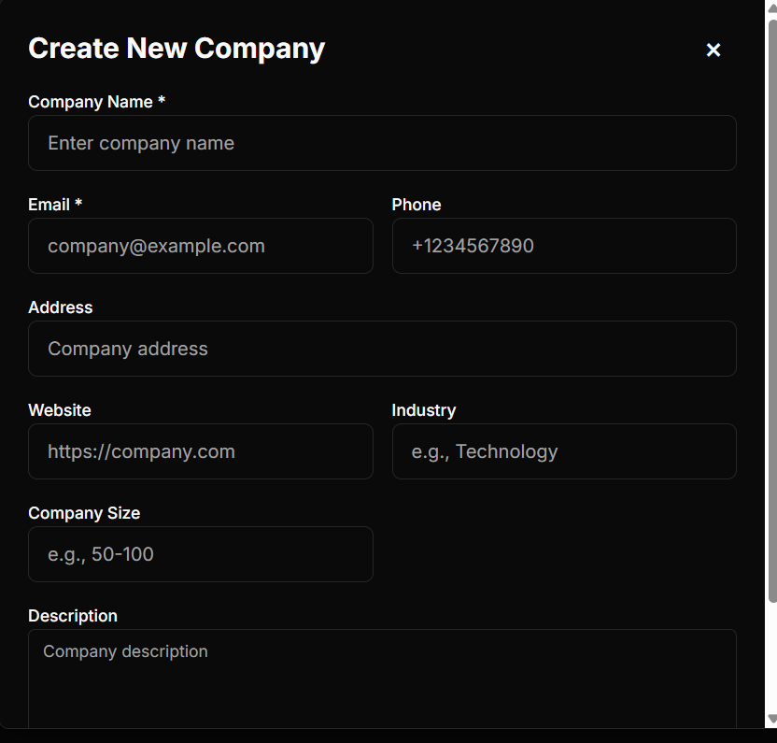
3.1 Company Creation

# | Test Case | Expected Result | Actual Result | Status
1 | Valid Email/Password | Successful creation. | Created successfully. | PASS
2 | Minimal Data Entry | Require email /password | Created with only email/password | PASS
3 | Invalid Email Format | Validation error. | Accepted comapny@gmail.co and, campanygmail.com@gmail.com. | FAIL
4 | Special Char Email | Validation error. | Accepted ~@gmail.com. | FAIL
5 | Invalid Name (@) | Validation error. | Accepted @ as name. | FAIL
6 | Duplication Company Name, Email | Validation error | Created Company | FAIL
7 | Dashboard Link Gen | Link generated & accessible. | Link generated correctly. | PASS
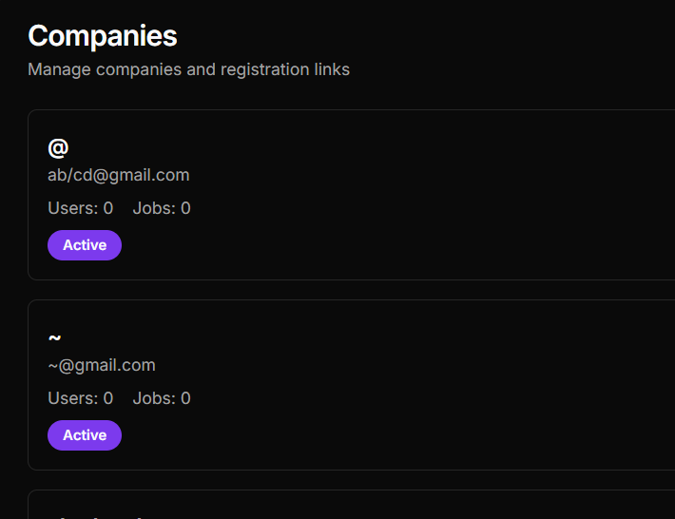
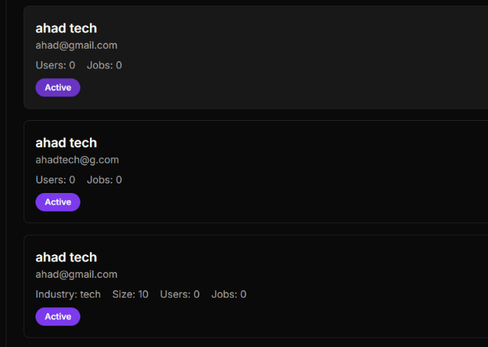

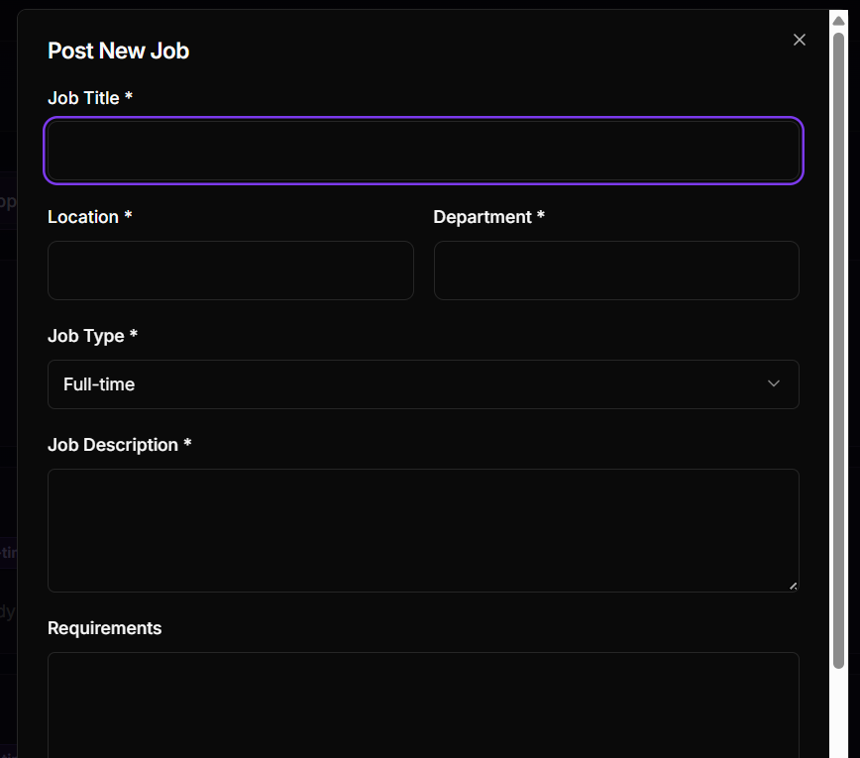
3.2 Job Posting
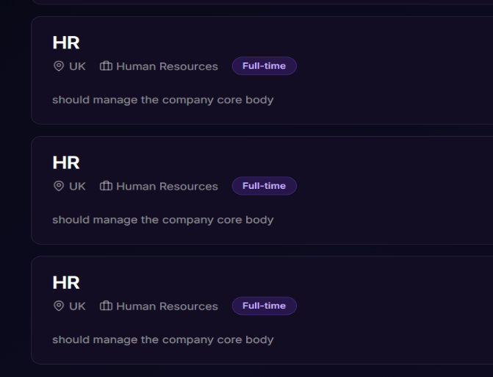

# | Test Case | Expected Result | Actual Result | Status
8 | Post Job Flow | Success alert; modal closes. | modal stayed open after clicking post button; created duplicates. | FAIL
9 | Input Validation | Validation error | Job was created with just random character like @ | FAIL
10 | Minimal Data Entry | Require title/ location/ department/ description | Created with them successfully | PASS

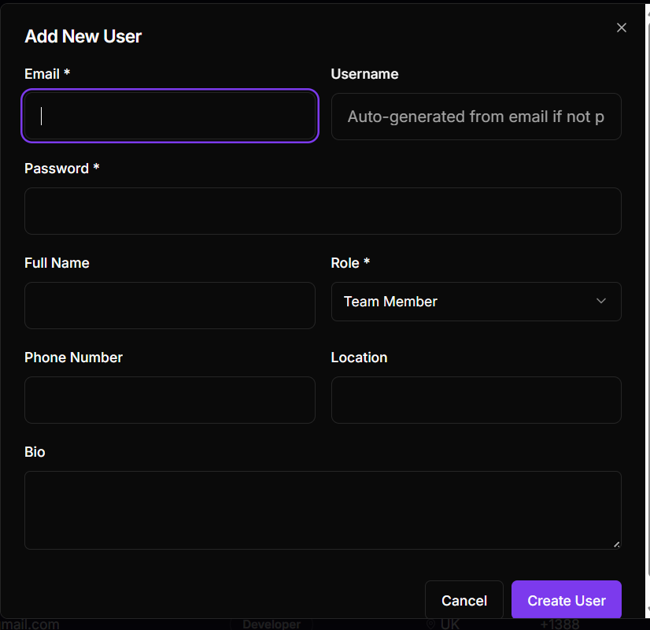
3.3 User Management

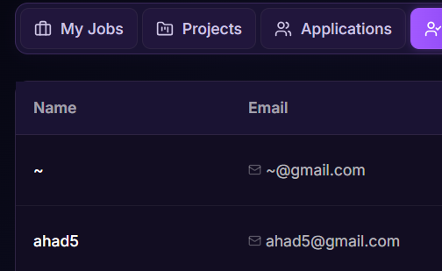

# | Test Case | Expected Result | Actual Result | Status
11 | Valid Data Entry | User created successfully. | Created successfully. | PASS
12 | Duplicate Email among users | Clear error message. | Blocked, with proper error already exists | PASS
13 | Duplicate Email with company mail | Clear error message. | Created the user with the same mail as company | FAIL
14 | Invalid Email Format | Validation error. | Accepted usergmail.com@gmail.com. And ~@gmail.com | FAIL
15 | Password Strength | Enforce complexity. | Only 6-char minimum enforced. | FAIL
16 | Reactivate User | Toggle to reactivate. | No option to reactivate. | FAIL
17 | Optional Fields | Clearly marked. | Email/Pass required; others optional. | PASS

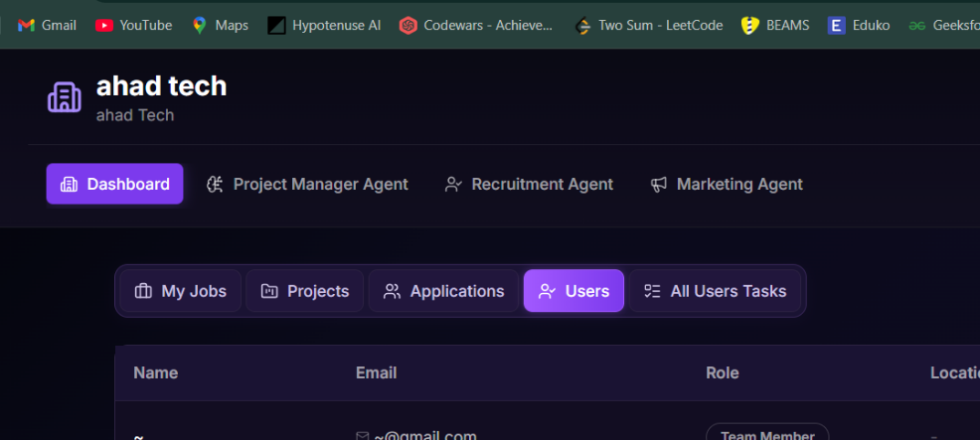
3.4 AI Employee Assignment

# | Test Case | Expected Result | Actual Result | Status
18 | Multiple Assignment | Assigned after payment. | Successful assignment. | PASS
19 | Cancel Payment | No assignment. | Correctly handled (not assigned). | PASS

3.5 Dashboard Display
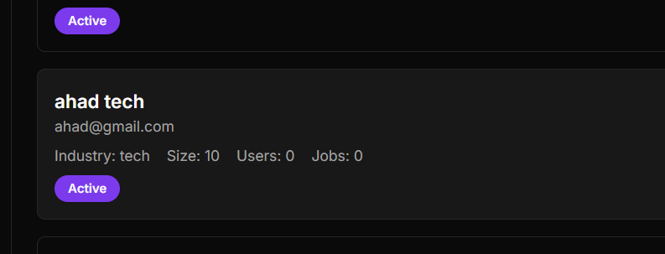

# | Test Case | Expected Result | Actual Result | Status
20 | Dashboard Stats of Admin | Show correct counts. | Shows 0 users/jobs despite data as shown in image. | FAIL
21 | Remove AI Employee option for company | Unassign option available. | No option to remove AI employee in company dashbaord | FAIL

4. Bug Log
Below are the high-priority issues that require developer attention.
Bug ID | Severity | Module | Description
BUG-001 | High | Job Posting | Modal stays open on submit; no loading state; results in duplicate entries.
BUG-002 | High | Validation | Email validation is missing or bypassed on all creation forms.
BUG-008 | High | Dashboard | Admin panel stats show "0" regardless of database state.
BUG-005 | Medium | User Management | Impossible to reactivate a user once deactivated (one-way operation).
BUG-006 | High | User Management | Have duplication in Email with company Emails.
BUG-007 | Medium | AI Management | No mechanism to unassign/remove an AI employee once added.
BUG-008 | Low | Security | Password policy is too weak (no special character/case requirements).

